SQL Lab 3 – Rideshare Data – Santander London

Trends & Descriptive Analysis – Santander London

1. **How many trips were there in each month of the year with Santander London?**

SELECT DATE_TRUNC('month',start_date) as month, COUNT(rental_id) AS monthly_rides

FROM public.santander_2016

GROUP BY 1

UNION

SELECT DATE_TRUNC('month',start_date) as month, COUNT(rental_id) AS monthly_rides

FROM public.santander_2017

GROUP BY 1

UNION

SELECT DATE_TRUNC('month',start_date) as month, COUNT(rental_id) AS monthly_rides

FROM public.santander_2018

GROUP BY 1

UNION

SELECT DATE_TRUNC('month',start_date) as month, COUNT(rental_id) AS monthly_rides

FROM public.santander_2019

GROUP BY 1

The result is 48 rows long, so I have only pasted the first 5 rows below. Full analysis in excel document. We can see seasonality changes in the results. Number of rides peaked in the UK summer, and is at the lowest in the first quarter of each year.

**Month**  **Number of Rides**

"2016-01-01 00:00:00+00" 443853

"2016-02-01 00:00:00+00" 593732

"2016-03-01 00:00:00+00" 659488

"2016-04-01 00:00:00+00" 781709

"2016-05-01 00:00:00+00" 1015114



1. **Which stations are showing the largest growth rate?**

SELECT DATE_TRUNC('month',start_date) as month, COUNT(startstationid), startstationid

FROM santander_2016

GROUP BY 1, 3

UNION

SELECT DATE_TRUNC('month',start_date) as month, COUNT(startstationid), startstationid

FROM santander_2017

GROUP BY 1, 3

UNION

SELECT DATE_TRUNC('month',start_date) as month, COUNT(startstationid), startstationid

FROM santander_2018

GROUP BY 1, 3

UNION

SELECT DATE_TRUNC('month',start_date) as month, COUNT(startstationid), startstationid

FROM santander_2019

GROUP BY 1, 3

I also ran the following to have a list of stations along with their ID’s in order to Index Match in excel.

SELECT id, name

FROM santander_stations;

I then put the findings into a pivot table, having the year in the columns, and stations in the rows. The resulting table showed the count of rides in each year from each station. After changing the ‘Show Data as’ tab to ‘% difference from’ and basing it off of the first value (usually January 2016, although some stations opened later). This then showed me the growth of the station from the first year up to the last year.

The results I found were that the highest growth as a % from early 2016 to the end of 2019 was Victory Place, Walworth (Station ID: 820) – however the data only included December of each year, so it may be that this station only operates over the Christmas period or holidays. This showed a growth rate of over 5000% - which as it is only open one month of the year isn’t a very good insight and may not be very representative. I have omitted this due to the short timeframe that this station is operating or has data for.

The second highest also had missing data, but this one at least had data from July to December of each year. This station was Ossulston Street, Somers Town (Station ID: 797). This station showed a growth of 227% from 2016-2019. To me, this is a more accurate representation of a realistic growth rate.



1. **If 2020 hadn’t been, well, 2020, what would you expect to have seen?**

Looking at the chart for question 1, we can assume that 2020 would show similar numbers as the previous years. There was a small amount of growth between 2016-2018, before a slight decline in growth for 2019. For obvious reasons, 2020 would not have looked like this in reality due to the Covid pandemic.

Running some quick queries to find the count of rides for each year, we can use the forecast function in excel in order to predict following values based off of previous data. Below is the line graph including a predicted count of rides for 2020.



SQL code:

SELECT COUNT(rental_id)

FROM santander_2016

SELECT COUNT(rental_id)

FROM santander_2017

SELECT COUNT(rental_id)

FROM santander_2018

SELECT COUNT(rental_id)

FROM santander_2019

After inputting the numbers into excel, I added a row for 2020 and then used the forecast function based on previous years’ data in order to predict the number of rides for 2020. The resulting count of rides for 2020 was 10,441,880. This is very slightly under the count of rides for 2018 (only 4 rides less in total!). This can be explained as the forecasting model will be taking into consideration the negative growth that Santander experienced in 2019.

1. **What was the longest journey? What do we know about it?**

**Distance (Km) Start Station End Station**

17.2 Stratford Station, Stratford Putney Rail Station, Putney

This journey starts in East London (Stratford) and ends in South West London (Putney) at a distance of 17.2km.

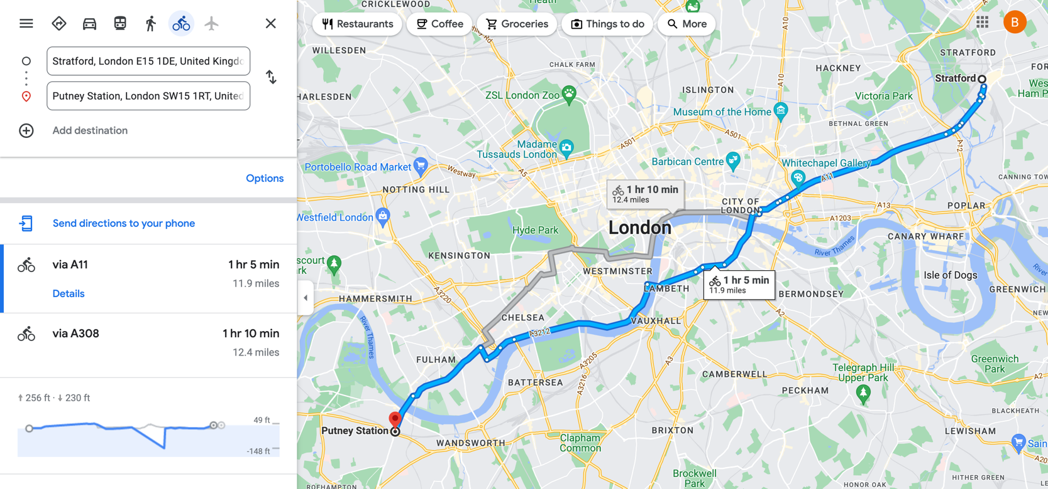The ride is approximately 1 hour and 5 minutes according to Google Maps.

WITH

name AS (

Select id, latitude, longitude, name, docks

FROM santander_stations),

ride_data AS (

SELECT startstationid, endstationid

FROM public.santander_2016

UNION

SELECT startstationid, endstationid

FROM public.santander_2017

UNION

SELECT startstationid, endstationid

FROM public.santander_2018

)

select calculate_distance (a.latitude, a.longitude, b.latitude, b.longitude, 'K'), a.name as Start_Station, b.name as End_Station

from name a, name b

WHERE a.id IN (SELECT startstationid FROM ride_data) and b.id IN (SELECT endstationid FROM ride_data)

ORDER BY 1 DESC

1. **How often do bikes need to be relocated?**

|  |  |  |  |  |  |  |  |
| --- | --- | --- | --- | --- | --- | --- | --- |
| |  |  | | --- | --- | | Rides | 4011 | | Relocations | 370 | | Relocation % | 9.22% | |  |

For this answer I have only used information from bike ID’s 1 – 5, as each ID had approximately 1000 rows associated with it. We can see that from 4011 rides, 370 bikes had to be relocated. This equates to 9.22%. If we find the total number of rides between 2016 – 2019, then this would come to approximately 3.7 million relocations over the 4 years. This is no easy feat and would require a lot of logistical work for drivers to move the bikes.

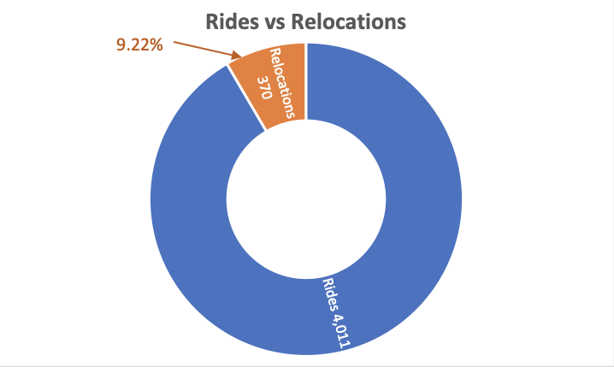

Code:

SELECT bike_id, startstationid, endstationid, start_date

FROM santander_2016

WHERE bike_id BETWEEN 1 AND 5

ORDER BY bike_id, start_date

I then put the findings into excel and ran an IF statement - =IF(B3=C2,0,1) – so that if the next ride had a different starting station from the previous one, it would show a 1. I then found the sum of all of the relocations and found the percentage.

1. **How far is a typical journey?**

For this one I have ran the same query as I did when finding the longest distance of a ride. I have calculated all possible distances between stations and then put this data into excel and ran a simple AVERAGE function in order to find the average distance. This would be typical of a usual journey that people would take.

|  |  |
| --- | --- |
| Mean | 7.31km |
| Max | 17.20km |
| Min | 0.00km |

The average journey distance comes in at 7.31km. The average cycle speed in London according to Strava (fitness app) is 22.5kph which equates to just under 20 minutes for an average cycle time. Some of the distances appear as 0, which can be correct as some people will start and end their journey at the same location.

The code I used is below – you will notice that I ran two separate queries to return the top 10,000 results and bottom 10,000 results, as there were far too many rows to export and PostGRE kept on crashing when I would try to export the data.

WITH

name AS (

Select id, latitude, longitude, name, docks

FROM santander_stations),

ride_data AS (

SELECT startstationid, endstationid

FROM public.santander_2016

)

select calculate_distance (a.latitude,

a.longitude, b.latitude, b.longitude,

'K'),

a.name as Start_Station,

b.name as End_Station

from name a,

name b

where a.id IN (SELECT startstationid FROM ride_data) and b.id IN (SELECT endstationid FROM ride_data)

ORDER BY 1 DESC

LIMIT 10000;

WITH

name AS (

Select id, latitude, longitude, name, docks

FROM santander_stations),

ride_data AS (

SELECT startstationid, endstationid

FROM public.santander_2016

)

select calculate_distance (a.latitude,

a.longitude, b.latitude, b.longitude,

'K'),

a.name as Start_Station,

b.name as End_Station

from name a,

name b

where a.id IN (SELECT startstationid FROM ride_data) and b.id IN (SELECT endstationid FROM ride_data)

ORDER BY 1 ASC

LIMIT 10000;